Project Report

**1. INTRODUCTION 2**

**2. NETWORK DESIGN 2**

2.1 Topology 2

2.2 Device Configuration Table 3

2.3 Cost Table 6

**3. EVIDENCE 7**

3.1 Overall Network [Final v10]: 7

3.2 IP Configuration for all devices: 8

3.4 Subnet Communication Evidence 14

3.5 Simulation Screenshots 21

**4. CHALLENGES AND SOLUTIONS 22**

5. CONCLUSION 26

# **1. INTRODUCTION**

The SleekCareSpa’s network design aims to support seamless operations at its new Las Vegas location. The objective is to create a robust, secure, and efficient network infrastructure that enhances staff productivity, streamlines guest services, and ensures reliable connectivity across all devices and locations within the facility. The network design focuses on employing a star topology, effective IP addressing, and logical subnetting to accommodate diverse operational needs.

# **2. NETWORK DESIGN**

## **2.1 Topology**

Within the router is a switch that isolates the guest devices and guest server within its own subnet and Vlan. Our router is connected with a gigabit connection to an MSwitch that allows IP routing for communication between its isolated subnets and Vlans. The access points are within their respective Vlans and subnets and set to different frequencies so as to not interfere with each other.

## **2.2 Device Configuration Table**

|  |  |  |  |  |  |  |  |  |
| --- | --- | --- | --- | --- | --- | --- | --- | --- |
| **Device** | **MAC Address** | **IP Address** | **IP Config** | **Subnet Group** | **Purpose** | **Location** | **Port** | **Connected Switch** |
| PC_FrontDesk1 | 0002.4A47.53D1 | 10.0.8.1 | Static | 10.0.8.0/24 | Appointment scheduling, customer management | Front Desk | Fa0/8 | M_Switch_Work - Vlan 80 |
| PC_FrontDesk2 | 0001.96B9.B624 | 10.0.8.2 | Static | 10.0.8.0/24 | Payment processing | Front Desk | Fa0/9 | M_Switch_Work - Vlan 80 |
| iPad_Sign_in | 00E0.F926.AEBC | 10.0.8.101 | DHCP | 10.0.8.100/24 | Digital sign-in for guests | Guest Sign-In Area | Fa0/10 | M_Switch_Work - Vlan 80 |
| iPad_Service1 | 0060.2F9C.C41D | 10.0.5.102 | DHCP | 10.0.5.100/24 | Access to client history and preferences | Service Room 1 | Fa0/7 | M_Switch_Work - Vlan 50 |
| iPad_Service2 | 000B.BE28.A667 | 10.0.5.103 | DHCP | 10.0.5.100/24 | Access to client history and preferences | Service Room 2 | Fa0/7 | M_Switch_Work - Vlan 50 |
| iPad_Service3 | 0030.A3EE.9C32 | 10.0.5.106 | DHCP | 10.0.5.100/24 | Access to client history and preferences | Service Room 3 | Fa0/7 | M_Switch_Work - Vlan 50 |
| iPad_Service4 | 000A.4164.BC6E | 10.0.5.101 | DHCP | 10.0.5.100/24 | Access to client history and preferences | Service Room 4 | Fa0/7 | M_Switch_Work - Vlan 50 |
| iPad_Service5 | 0060.47B1.DA3C | 10.0.5.104 | DHCP | 10.0.5.100/24 | Access to client history and preferences | Service Room 5 | Fa0/7 | M_Switch_Work - Vlan 50 |
| iPad_Service6 | 0002.4A04.7E1C | 10.0.5.105 | DHCP | 10.0.5.100/24 | Access to client history and preferences | Service Room 6 | Fa0/7 | M_Switch_Work - Vlan 50 |
| PC_Boss | 0005.5EC6.B900 | 10.0.3.1 | Static | 10.0.3.0/24 | Managing business operations | Boss Office | Fa0/3 | M_Switch_Work - Vlan 30 |
| PC_Manager | 0050.0F6A.345D | 10.0.3.2 | Static | 10.0.3.0/24 | Managing business operations | Manager Office | Fa0/4 | M_Switch_Work - Vlan 30 |
| PC_Consultant1 | 0030.A3C1.0DBD | 10.0.5.1 | Static | 10.0.5.0/24 | Conducting client consultations | Consultation Room 1 | Fa0/5 | M_Switch_Work - Vlan 50 |
| PC_Consultant2 | 000B.BEE1.051A | 10.0.5.2 | Static | 10.0.5.0/24 | Conducting client consultations | Consultation Room 2 | Fa0/6 | M_Switch_Work - Vlan 50 |
| Smartphones_Employee | 0001.C7AE.1310 | 10.0.1.101 | DHCP | 10.0.1.100/24 | Personal and business access | Employee Area | Fa0/1 | M_Switch_Work |
| Smartphones_Guest | 00E0.B0E2.09A3 | 192.168.1.101 | DHCP | 192.168.1.100/24 | Wi-Fi access for guests | Guest Area | Fa0/0/0 | Router_SleekSpa - Vlan 100 |
| Server_Guest | 00D0.D3D2.4304 | 192.168.1.20 | Static | 192.168.1.0/24 | Provides guest DHCP & DNS | Guest Area | Fa0/0/1 | Router_SleekSpa - Vlan 100 |
| Server_Work | 0001.43D7.D542 | 10.0.2.20 | Static | 10.0.2.0/24 | Provides employee DHCP & DNS | Employee Area | Fa0/2 | M_Switch_Work - Vlan 20 |
| Router_SleekSpa | 0090.0C82.6901 | N/A | Static | Multiple Subnets | Core network routing and gateway | Server Room | Multiple | Connected to all VLANs via MSwitch_Work |
| MSwitch_Work | 00e0.b079.b801 | N/A | Static | Multiple Subnets | Core switching device for all VLANs | Central Area | Multiple | Router_SleekSpa & all devices |

## 

## **2.3 Cost Table**

|  |  |  |  |
| --- | --- | --- | --- |
| **Device** | **Quantity** | **Price per unit** | **Total Cost** |
| **Router:** [**Cisco 2911**](https://www.cablesandkits.com/networking/equipment/routers/cisco-routers/cisco2911-k9/pro-7251/?srsltid=AfmBOopkd9sezwwebwFOuGAJWBs7AK5qkLalXoh2tVl8PkdqfW6L5ppK) | **1** | **$119** | **$119** |
| **Router Module:** [**Cisco 4-Port HWIC-4ESW**](https://www.cablesandkits.com/networking/equipment/modules/cisco-modules/cisco-routing-modules/4-port-single-wide/pro-894/?srsltid=AfmBOoqMwKx4Gj-MWP87TpG0NoVFLKnzO-ePK3PtXOVpWeqGrwna-lqr) | **1** | **$100** | **$100** |
| **MSwitch:** [**Cisco Catalyst 3560-24PS**](https://www.cablesandkits.com/mc/networking/equipment/switches/cisco-switches/cisco-3650-series/switches/3560-poe/fam-91/fp-1438/?srsltid=AfmBOooYBHH6Z_NTCA9IyaB6fjLPS3H-KSaK09VQkZ-sKVOxtvHZCJCr) | **1** | **$201** | **$201** |
| **Server:** [**Cisco B200 M4 Server**](https://www.cablesandkits.com/mc/servers/b200m4/fam-359/fp-9976/) | **2** | **$465** | **$930** |
| **Access Point:** [**Cisco Catalyst 9105AX**](https://www.cablesandkits.com/networking/equipment/access-points/cisco-access-points/c9105ax-b/pro-24516/) | **4** | **$260** | **$1040** |
| **Desktop:** [**HP All-in-One 27-cr0000m**](https://www.hp.com/us-en/shop/pdp/hp-all-in-one-27-cr0000m-27-947r2av-1?jumpid=cs_con_nc_ns&utm_medium=cs&utm_source=ga&utm_campaign=HP-Store_US_All_CPS_All_AMD_Google_All_Smart-PLA_Bestseller&utm_content=sp&adid=&addisttype=xpla&947R2AV_1&cq_src=google_ads&cq_cmp=20537729678&cq_con=&cq_term=&cq_med=pla&cq_plac=&cq_net=x&cq_pos=&cq_plt=gp&gad_source=1&gclid=Cj0KCQiAo5u6BhDJARIsAAVoDWv5iVoMh75HdnmHH08V_pdHdZ61WJUQ7urgsR9UWO88mi7W-Hnf4H4aAmKHEALw_wcB&gclsrc=aw.ds) | **6** | **$400** | **$2400** |
| **iPad:** [**Apple iPad [10th gen]**](https://www.target.com/p/apple-ipad-10-9-inch-wi-fi-64gb-2022-10th-generation-blue/-/A-85966332?sid=&ref=tgt_adv_xsp&AFID=google_pla_df&fndsrc=tmnv&DFA=71700000120204038&CPNG=PLA_DVM%2Ba064R0000155fEMQAY-Apple_BMP_HW_Q3_2024_EOQ-1440294&adgroup=PLA_Apple_HW&LID=700000001393753pgs&network=g&device=c&location=9030803&gad_source=1&gclid=Cj0KCQiAo5u6BhDJARIsAAVoDWsMF4CNmWs4JfxF45t3Drj69QiRldpE6S1HLn5XnyO7Dvg2xQqw9QAaAjMdEALw_wcB&gclsrc=aw.ds) | **7** | **$300** | **$2100** |
| **Cable (100ft):** [**Cat5e Ethernet Patch Cable**](https://www.cablesandkits.com/mc/ethernet/cat5e-booted/fam-11/fp-18354/?color=Black&length=100) | **13** | **$19** | **$247** |
| **Total Cost** |  |  | **$7137** |

# **3. EVIDENCE**

## **3.1 Overall Network [Final v10]:**

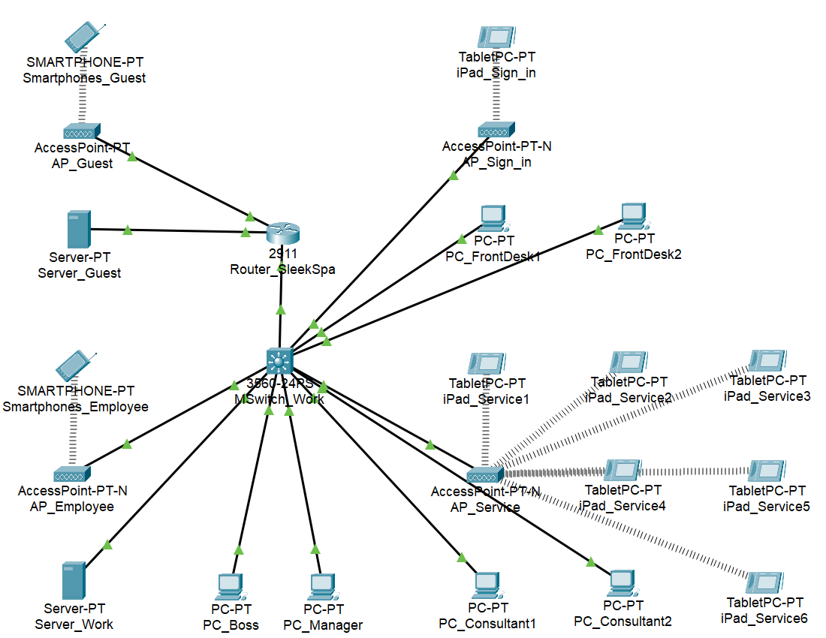

## **3.2 IP Configuration for all devices:**

**PC_ FrontDesk1**

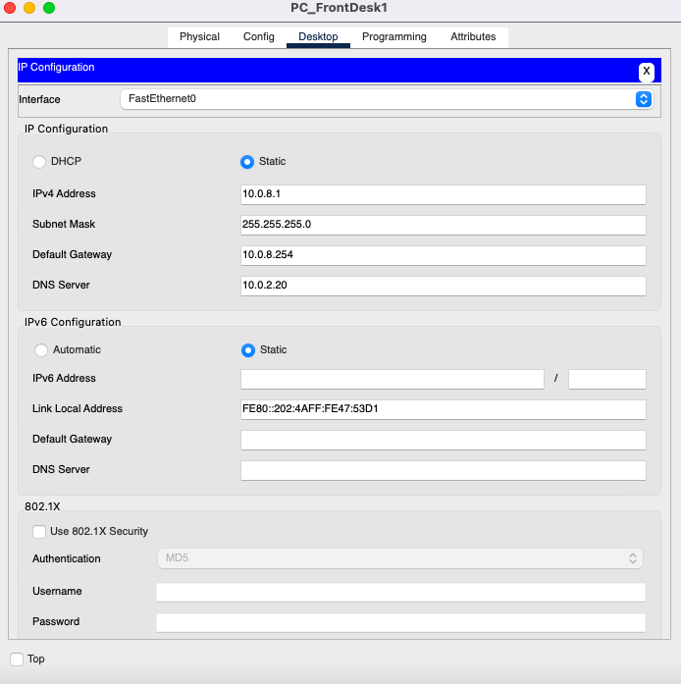

**PC_FrontDesk2**

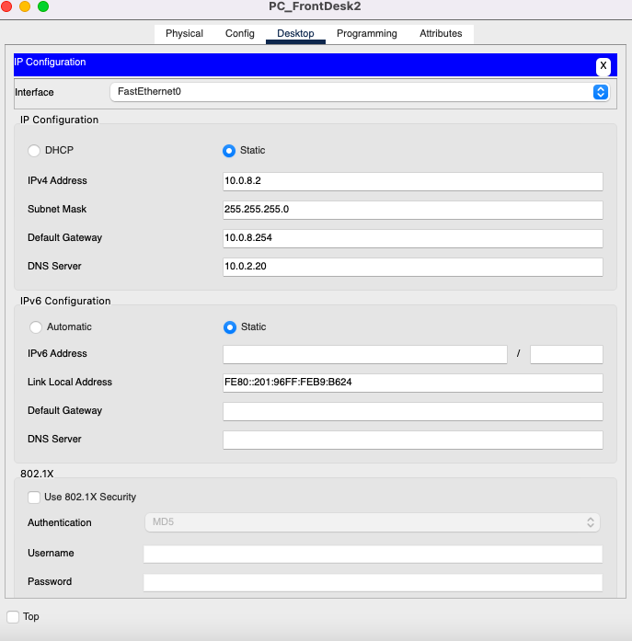

**Guest Sign-In iPad**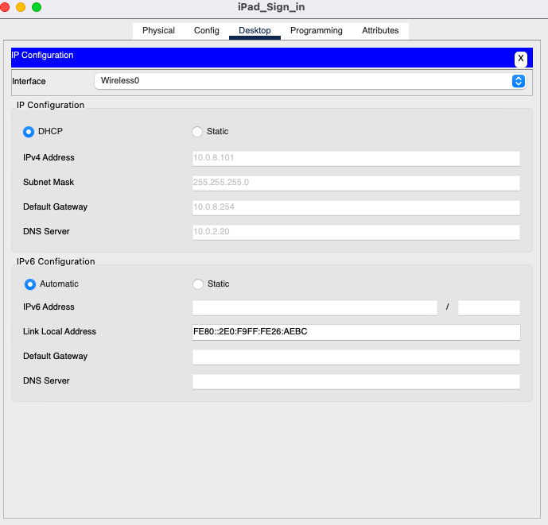

**Service Room iPad 1**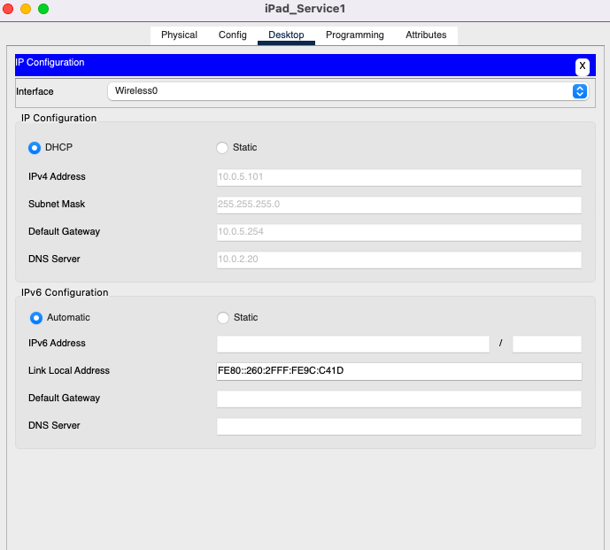

**Service Room iPad 2**

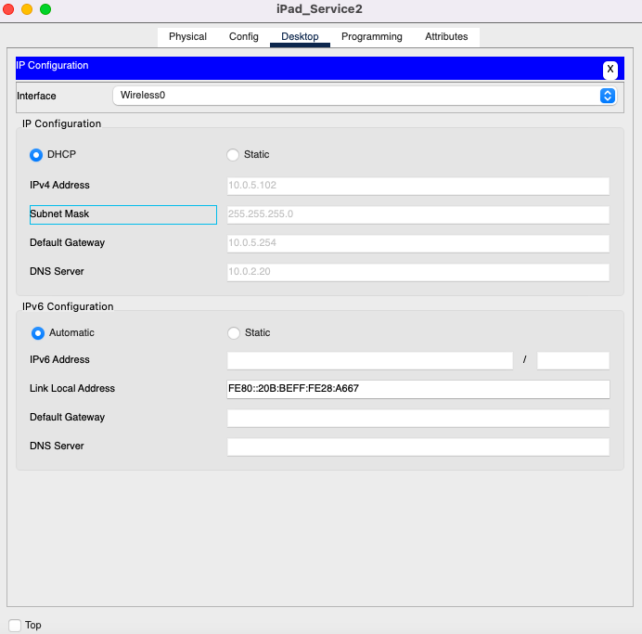

**Service Room iPad 3**

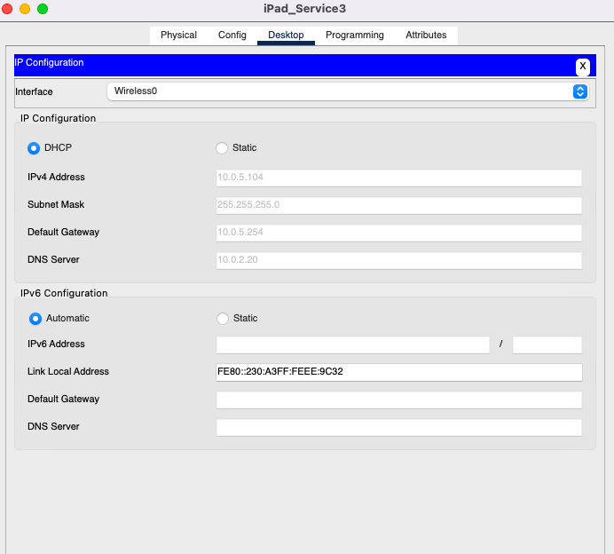

**Service Room iPad 4**

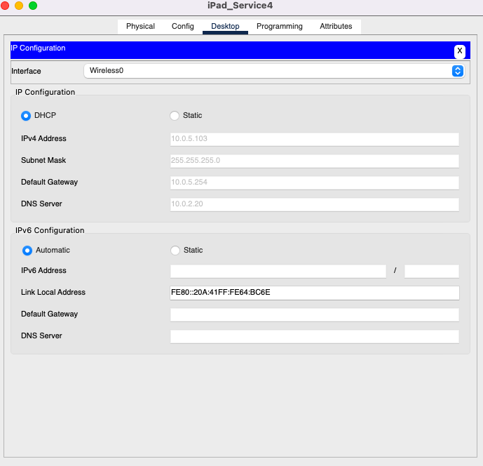

**Service Room iPad 5**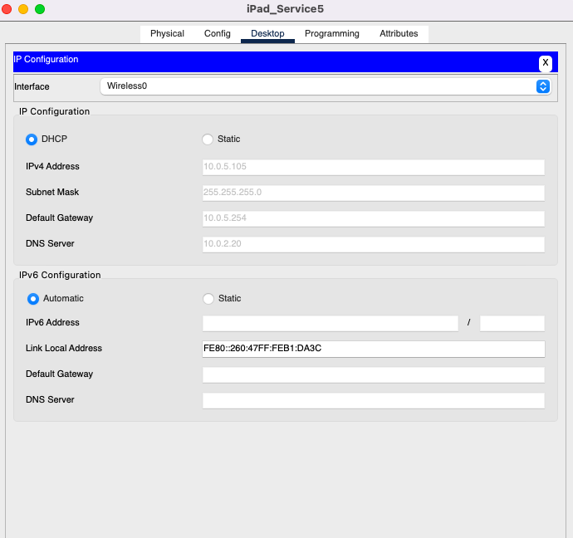

**Service Room iPad 6**

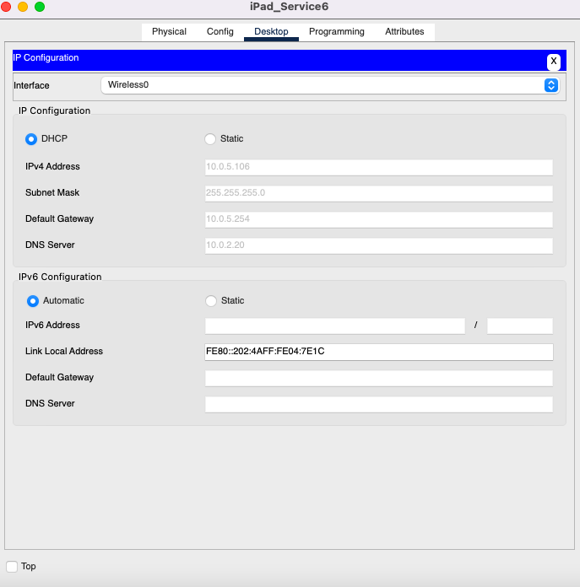

**Boss Office Computer**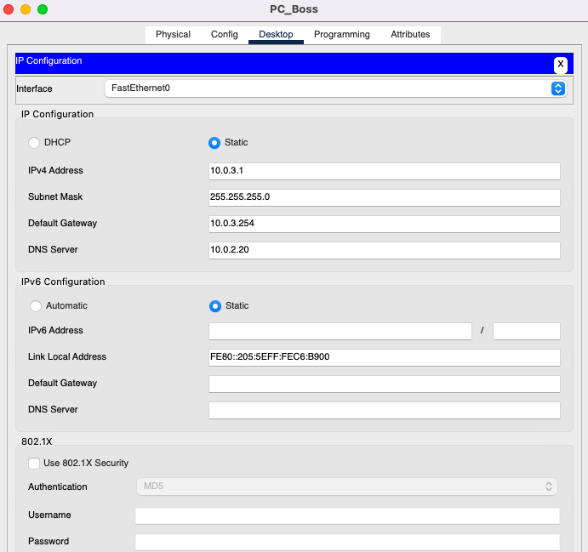

**Manager Office Comp**

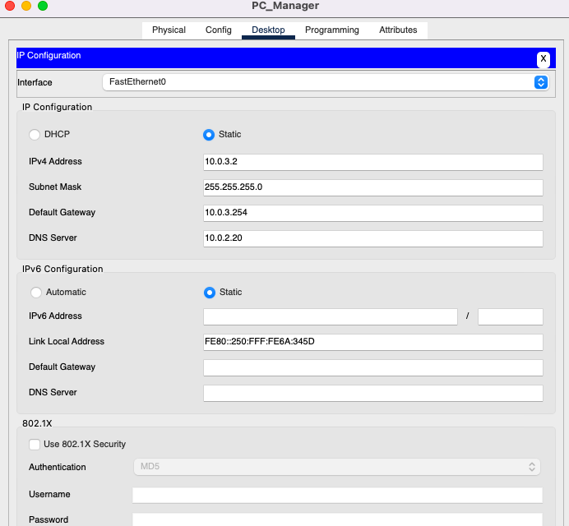

**Consultation Room 1**

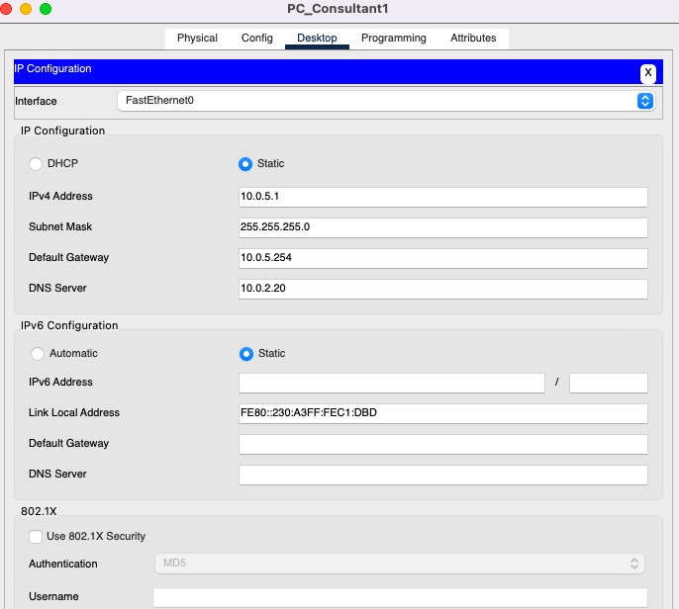

**Consultation Room 2**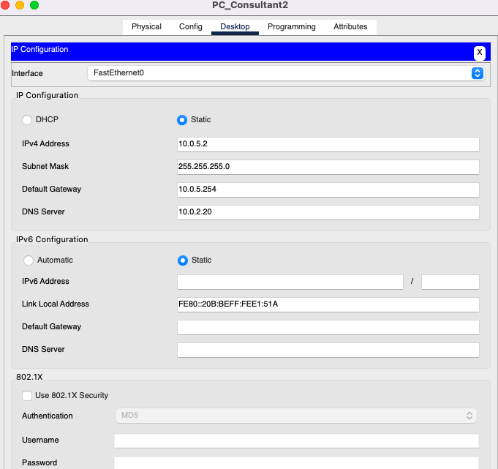

**Employee Personal Device**

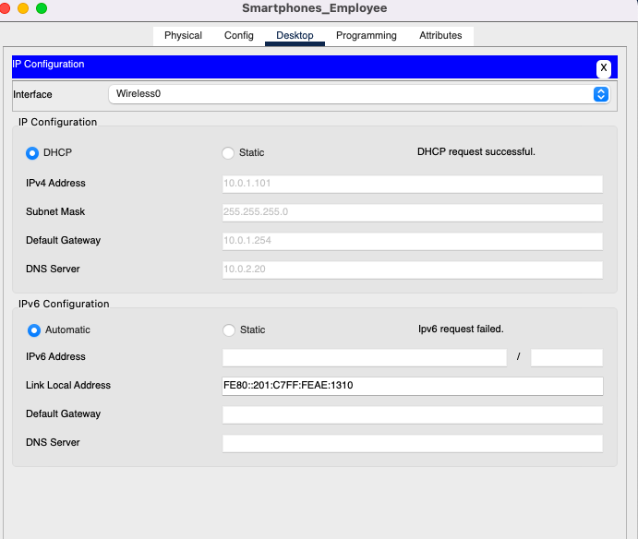

**Guest Mobile Device**

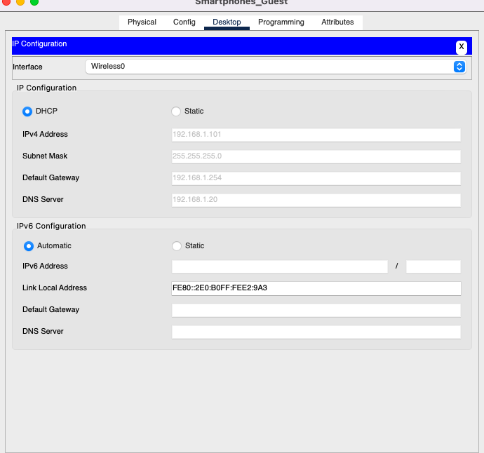

## 

## 

## **3.4 Subnet Communication Evidence**

**Smartphones_Guest -> Server_Guest**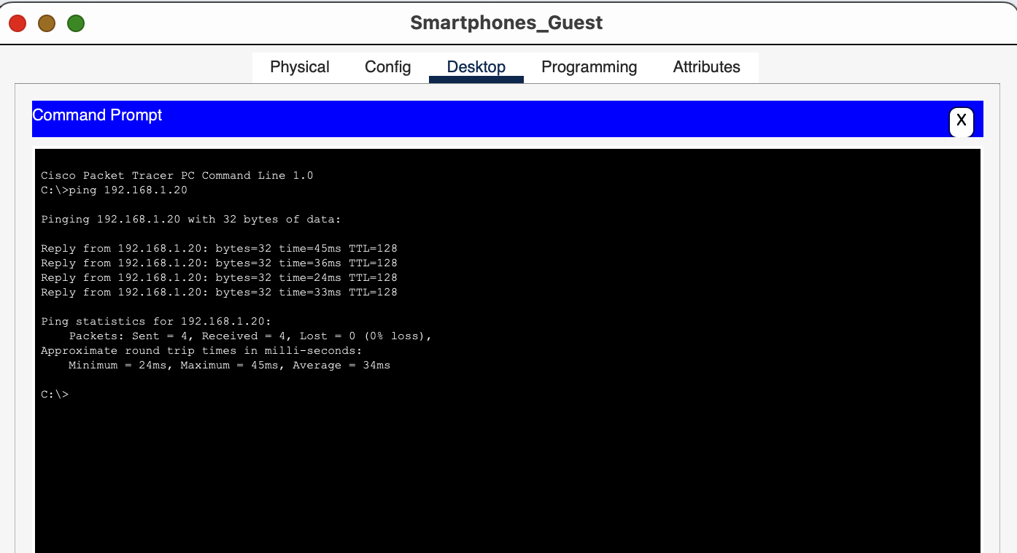

**Smartphones_Employee -> Server_Work**

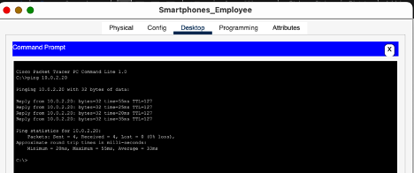

**PC_FrontDesk1 -> PC_Boss** 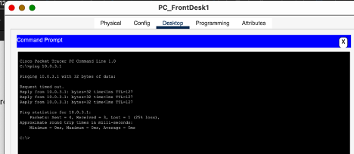

**PC_FrontDesk2 -> PC_Boss** 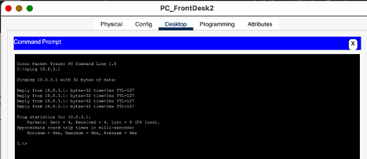

**PC_FrontDesk1 -> PC_Manager** 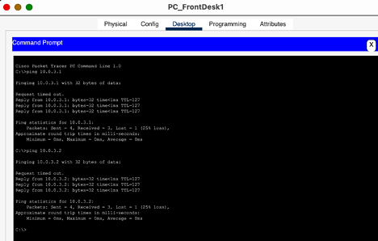

**PC_FrontDesk2 -> PC_Manager** 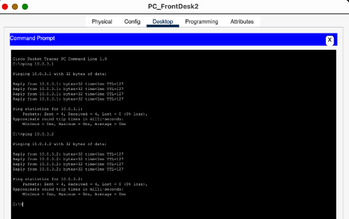

**iPad_Service1 -> Server_Work** 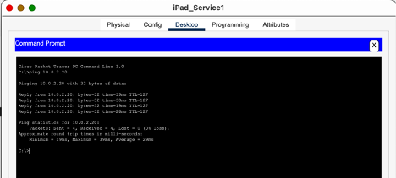

**iPad_Service2 -> Server_Work** 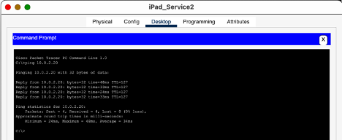

**iPad_Service3 -> Server_Work** 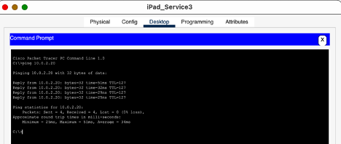

**iPad_Service4 -> Server_Work** 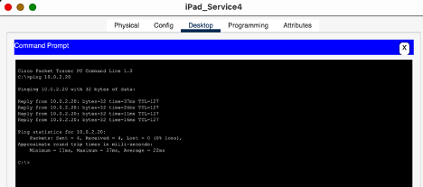

**iPad_Service5 -> Server_Work** 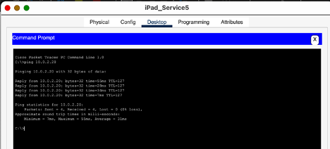

**iPad_Service6 -> Server_Work** 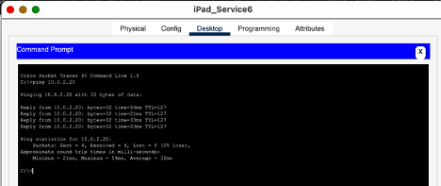

**PC_FrontDesk2 -> PC_FrontDesk1**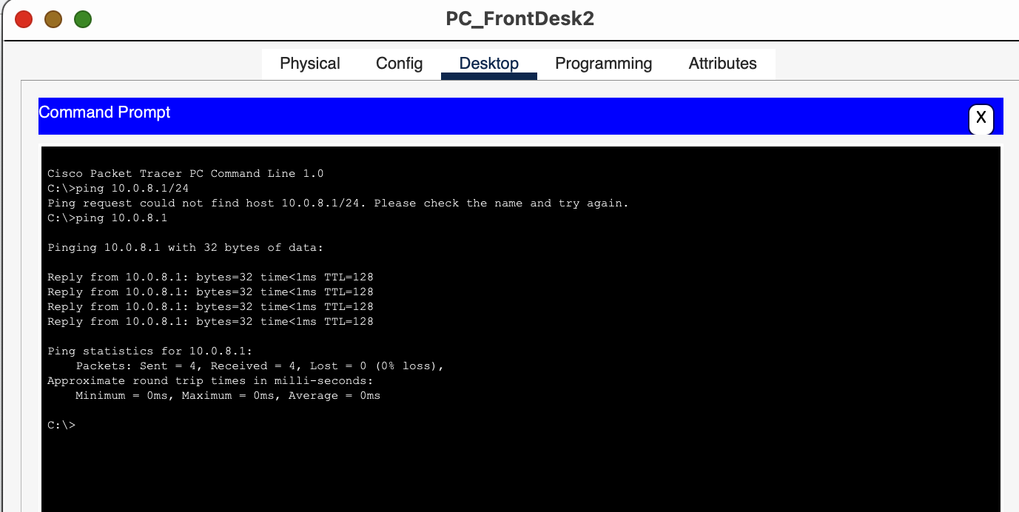

**PC_Boss -> PC_Manager**

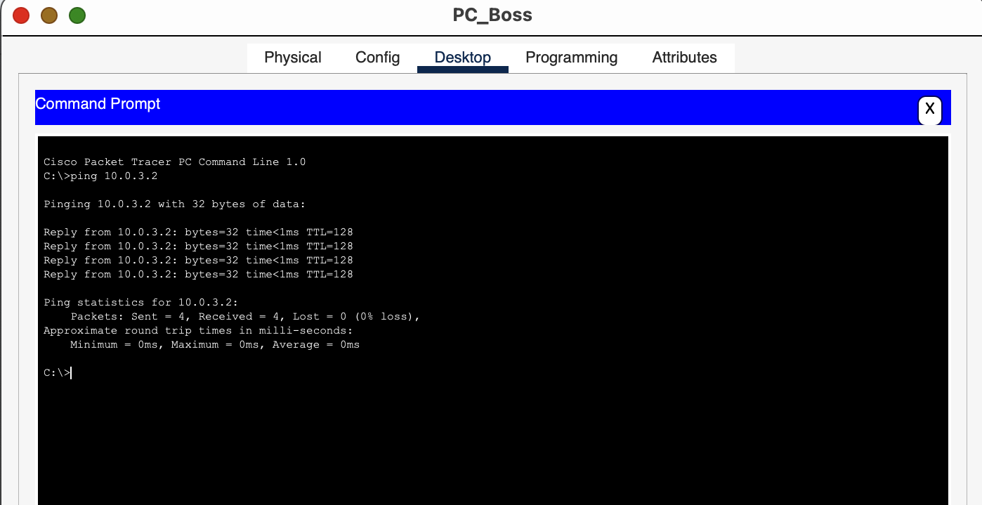

**PC_Consultant1 -> PC_Boss, PC_Manager, PC_FrontDesk1** 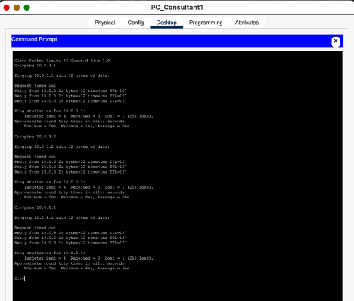

**PC_Consultant2 -> PC_Boss, PC_Manager, PC_FrontDesk2** 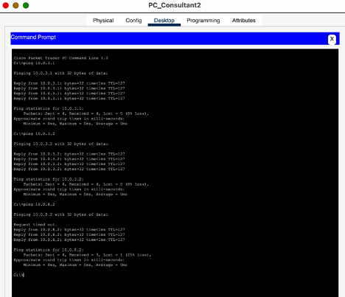

**PC_Consultant2 -> PC_Consultant1**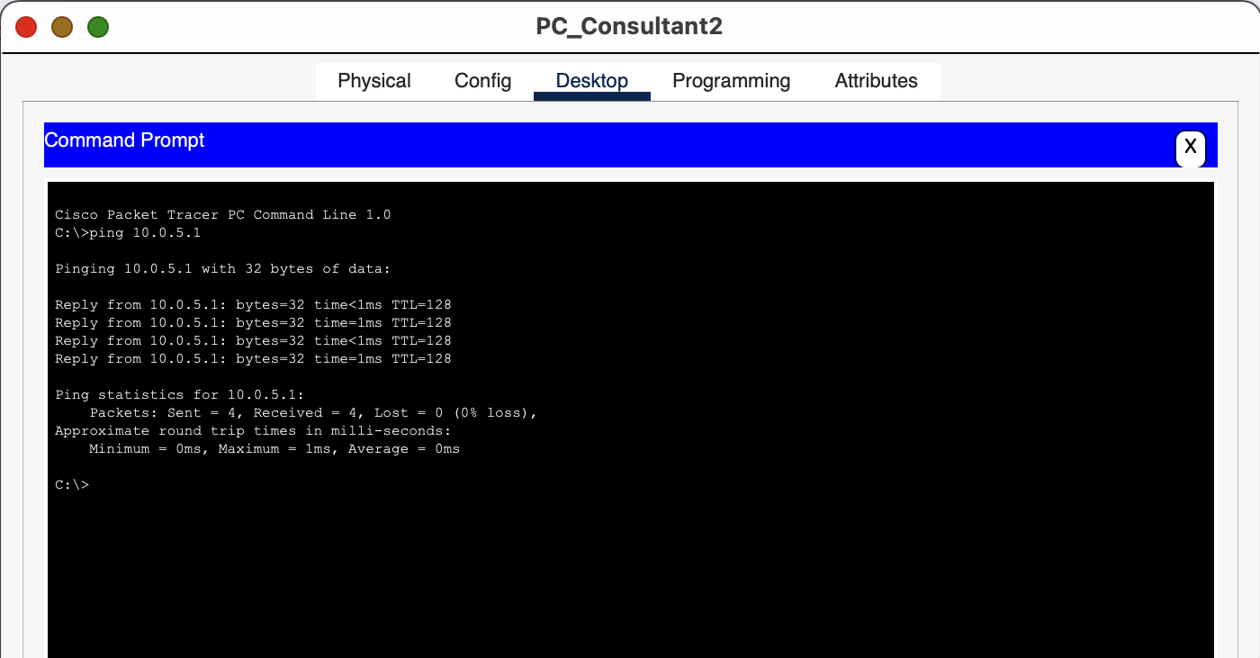

**SmartphoneGuest isolated and unable to ping outside own VLAN/Subnet:**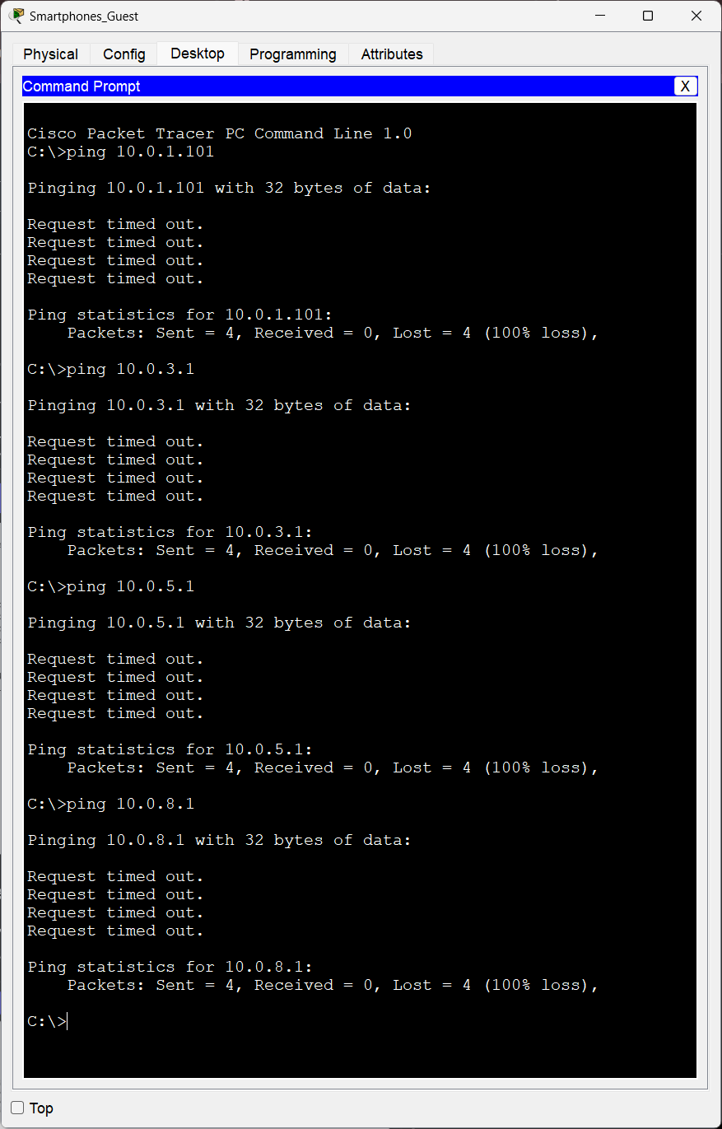

## **3.5 Simulation Screenshots**

## 

## 

# **4. CHALLENGES AND SOLUTIONS**

**4.1 Technical challenge: Creating Vlans and setting Gateways:**

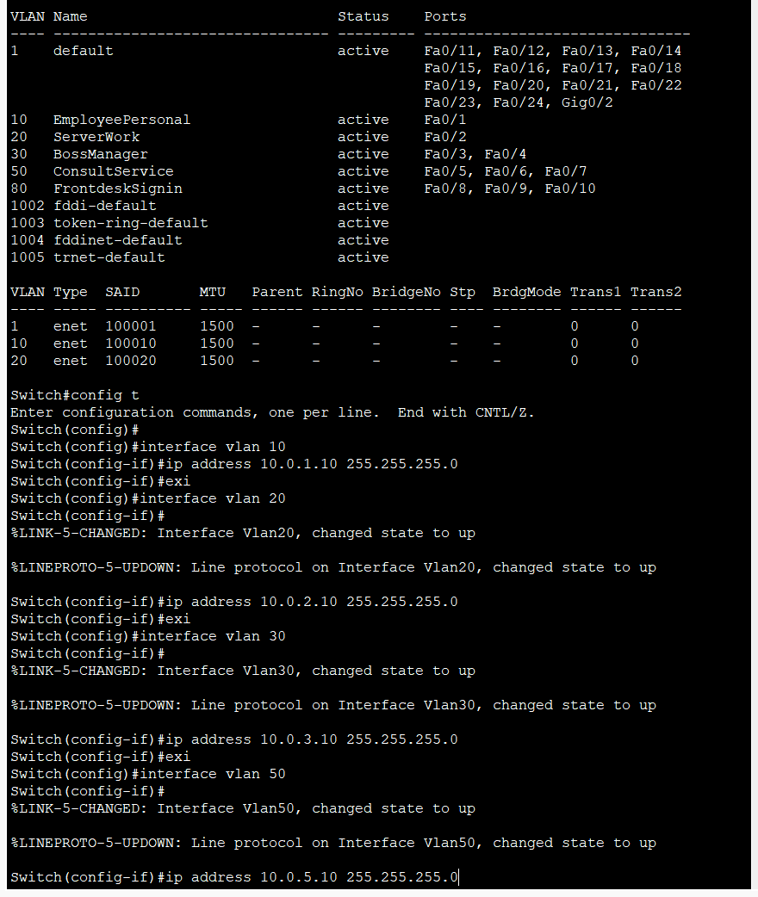

* **Challenge:** Difficulty in creating VLANs and assigning appropriate gateways.
* **Solution:** Configured VLANs using Vlan commands and assigned correct gateway IPs for each VLAN. Verified connectivity using Ping tests.

**4.2 Technical challenge: DHCP server integration with Vlans on switch with ip routing:**

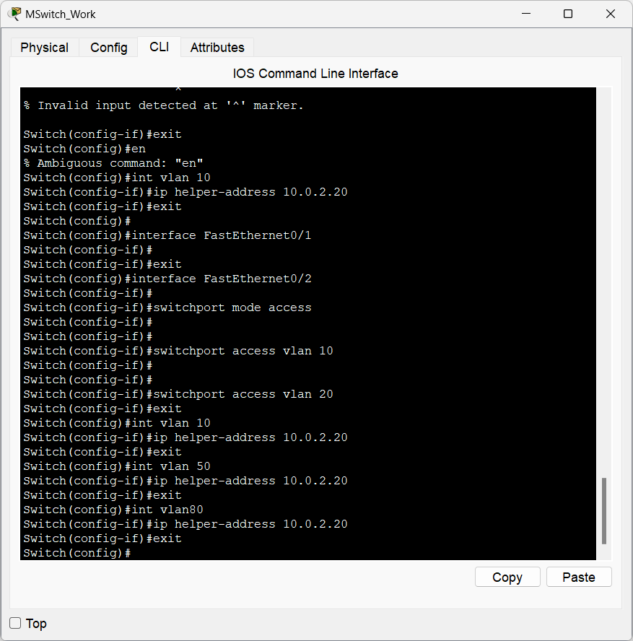

* **Challenge:** DHCP requests were not propagating across VLANs and VLANs were not talking to each other.
* **Solution:** Configured the router and switch as a DHCP relay using the ip helper-address command. Changed to an Mswitch to enable ip routing. Ensured the correct gateway IPs were assigned to each VLAN. This allowed seamless DHCP integration with VLANs.

**4.3 Technical Challenge: Network Diagram Version Improvements:**

* **Challenge:** Iterative improvements to the network diagram required validating configurations and ensuring consistency.

**4.3.1 Version 1**

Initial draft with basic topology.

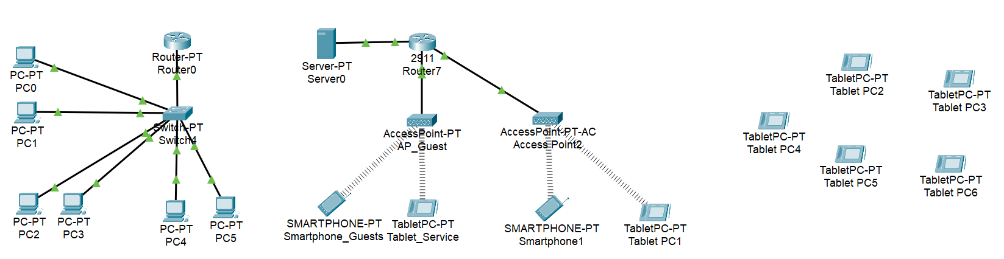

**4.3.2 Version 2**

Updated with VLAN segmentation.

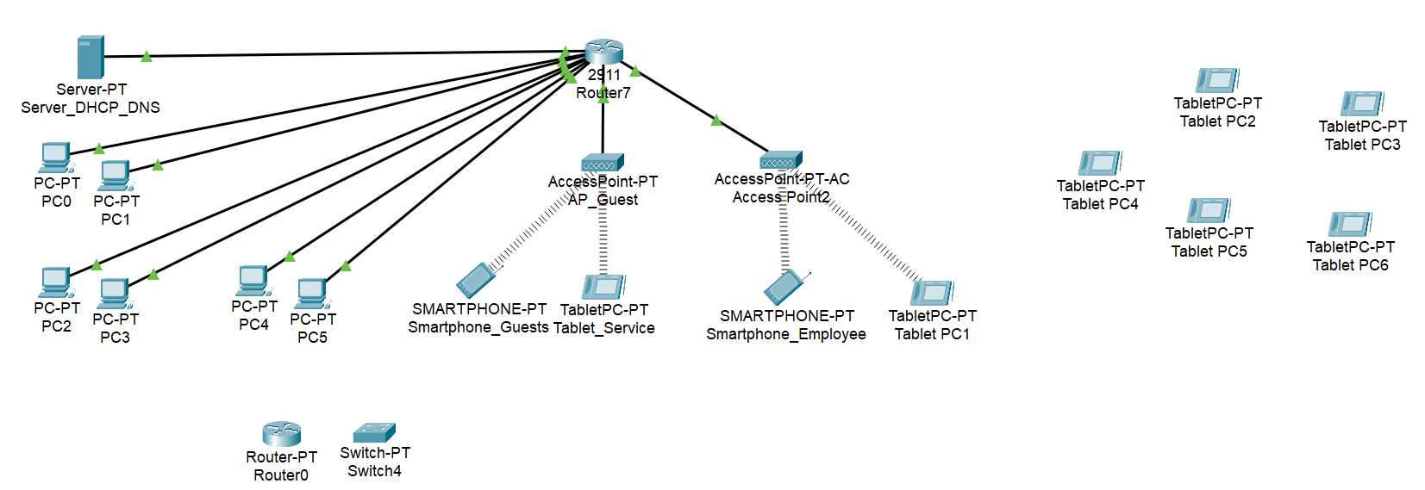

**4.3.3 Version 3**

Integrated DHCP server configuration and IP routing for inter-VLAN communication.

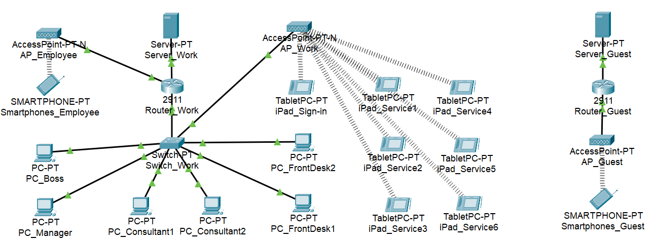

**4.3.4 Version 4**

Multi-switch solution before final version (Single MSwitch) with all configurations validated and optimized for performance.

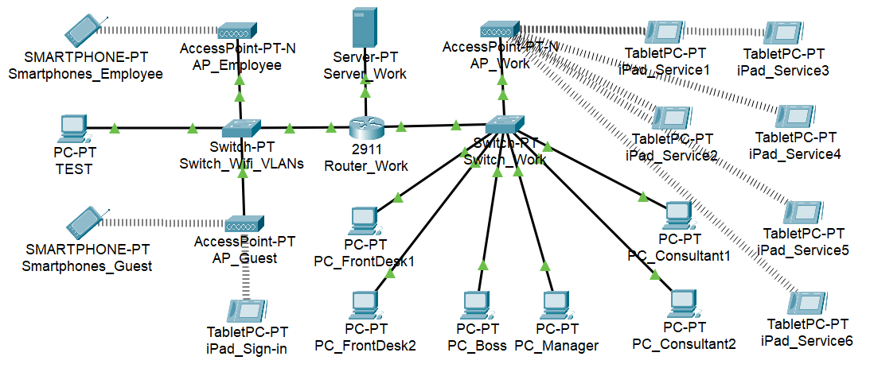

"One major challenge was setting up DHCP for multiple VLANs. Initially, DHCP requests were not propagating. This was resolved by configuring the router as a DHCP relay and ensuring correct gateway assignments."

### **5. CONCLUSION**

The SleekCareSpa network design successfully establishes a **robust, secure, and efficient technological infrastructure** for the Las Vegas location. By implementing a strategic **star topology** with **careful network segmentation**, the system achieves the following key objectives:

* **Seamless Operational Connectivity:** Ensures uninterrupted communication across front desk, service rooms, and administrative spaces. Our Mswitch has been configured to optimize data traffic and allow VLANs to speak to each other while getting dynamic DHCP ip addresses from a server on its own VLAN.
* **Enhanced Network Security:** Distinguishes between employee and guest network access to protect sensitive data.The guest access point and server that provides DHCP/DNS are isolated on their own VLAN that blocks guest devices from accessing anythings else on the network.
* **Scalability:** Leverages Cisco networking equipment to accommodate future expansion. Our configuration allows for scalability with additional open ports on both our Router and MSwitch, two separate isolated servers, and multiple access points on their own VLANs for hot swapping components when upgrades are required.
* **Device Integration:** Supports a wide range of devices tailored to specific business functions. By using devices with advanced features like ip routing on our MSwitch and access points with 2.4 and 5ghz channels; we can integrate many more devices if necessary.
* **Cost-Effective Performance:** Balances high-performance requirements with budget-friendly solutions. We have achieved optimal cost effectiveness while maintaining features in our MSwitch, Access Points, Ethernet cables, and Router (with switch module). There is room for cost saving by minimizing the capabilities (and price) of the following items to meet the needs of the network: Servers, Desktops, iPads. While our access points could also be purchased for less if separate 2.4 and 5ghz bands are not required, the biggest cost savings would be to optimize the end point devices for the business needs.

The **network infrastructure** not only facilitates essential business operations like **appointment scheduling** and **payment processing** but also lays the groundwork for **future growth** and **digital transformation**. We are proud of the network configuration we have finalized for SleekCare Spa and learned a lot from working together on this project.